

A PROJECT REPORT

ON

AI Agent for Missing Person Information Management

A project report submitted in partial fulfilment of the requirements for the degree of Bachelor of Technology in Computer Science and Engineering

BACHELOR OF TECHNOLOGY COMPUTER SCIENCE AND ENGINEERING

Submitted By
Paarth Maheshwari 24070521050

UNDER THE GUIDANCE OF

Dr. Parag Naik

Subject Teacher

DEPARTMENT OF COMPUTER SCIENCE AND ENGINEERING
AY 2026-27
DEPARTMENT OF COMPUTER SCIENCE AND ENGINEERING

CERTIFICATE
This is to certify that the Project work entitled “<Title of the Project>” is carried out by the <Name of the Students>, in partial fulfillment for the award of the degree of Bachelor of Technology in Computer Science and Engineering, Symbiosis International (Deemed University), Pune during the academic year 2026-2027.

Dr. Parag Naik  Subject Teacher |  | Dr. Shreyas Rajendra Hole  Subject Coordinator

DECLARATION
I hereby declare that the project titled AI Agent for Missing Person Information Management submitted to Symbiosis Institute of Technology, a constituent of Symbiosis International (Deemed University) Pune, for the award of the degree of Bachelor of Technology in Computer Science and Engineering, is a result of original research carried out by me. I understand that my report may be made electronically available to the public. It is further declared that the project report or any part thereof has not been previously submitted to any University or Institute for the award of any degree or diploma.
Name of Student: Paarth Maheshwari (24070521050)

Degree: Bachelor of Technology in CSE
Department: Computer Science and Engineering
Title of the project: AI Agent for Missing Person Information Management

Paarth Maheshwari
Date: 20/09/2026

Dr. Shreyas Rajendra Hole

Mr. Parag Naik

ABSTRACT
The increasing availability of digital information and advances in Artificial Intelligence have created opportunities to develop intelligent systems that can assist in the organization, retrieval, and analysis of information related to missing-person cases. Traditional investigation workflows often require information to be collected from multiple sources, examined individually, and manually compared before useful conclusions can be formed. This project presents an AI-Powered Missing Person Investigation Assistant designed as a prototype to demonstrate how an AI agent can assist with such an information-search and investigation workflow. The proposed system combines a locally deployed Large Language Model (LLM), a structured synthetic missing-person case database, an external web-search service, and an interactive web-based interface.
The system uses Qwen3 14B as the primary reasoning model and runs it locally through Ollama, reducing the need to send the core reasoning process to an external language-model service. The AI agent is provided with multiple tools that it can select according to the requirements of a user's investigation query. These tools include a structured case-search function for finding records based on parameters such as location, age, and gender; a case-retrieval function for obtaining complete information about a particular case; and a web-search function powered by the Tavily API for retrieving potentially relevant information from external web sources. This tool-based architecture allows the system to move beyond a conventional question-answering chatbot by enabling the language model to determine which sources and operations are required to respond to an investigation request.
An interactive interface is developed using Gradio, allowing users to enter natural-language investigation queries and receive structured investigation reports without directly interacting with the underlying Python implementation. The interface also displays the activity performed by the agent, allowing users to observe when the system searches the internal case database, retrieves a specific case, or performs an external web search. The resulting information is then provided back to the local language model, which analyzes the retrieved data and generates a consolidated response. This demonstrates an agentic workflow in which the LLM acts as a reasoning component that can select and utilize external tools rather than simply generating an answer from its pretrained knowledge.
For controlled experimentation and demonstration, the project uses a synthetic missing-person dataset containing fictional case records. Each record contains structured attributes such as case ID, name, age, gender, last-seen location, missing date, physical description, and case status. The use of synthetic data ensures that the prototype does not expose or process real personal information while still allowing the complete investigation workflow to be demonstrated. Similarly, information retrieved through external web search is treated as supplementary information and is not considered proof of identity or a confirmed match. The system therefore focuses on information retrieval, organization, and AI-assisted analysis rather than automated identification or decision-making.
The project demonstrates the integration of several modern technologies, including Large Language Models, local AI inference, function/tool calling, structured data retrieval, web-search APIs, and rapid web application development. By combining these components, the proposed system provides a practical example of how AI agents can be designed to interact with multiple information sources and dynamically determine the steps required to answer a user's query. The prototype also provides a foundation that could be extended in future work with larger verified databases, advanced document retrieval, image-based search, geographic information systems, multilingual interaction, authentication, and other investigation-support capabilities. However, such extensions would require appropriate privacy, security, verification, and ethical safeguards before any real-world deployment.
Keywords— Artificial Intelligence, AI Agents, Large Language Models, Missing Person Investigation, Qwen3, Ollama, Tavily API, Gradio, Tool Calling, Local LLM, Web Search, Information Retrieval, Synthetic Dataset, Intelligent Investigation Assistant

TABLE OF CONTENTS

Page

Certificate i
Declaration ii
Abstract iv
Table of Contents v
CHAPTER 1: BACKGROUND AND TECHNICAL OVERVIEW 1
CHAPTER 2: PROBLEM STATEMENT AND MOTIVATION 3
CHAPTER 3: NOVELTY AND INNOVATIVE CONTRIBUTIONS 4
CHAPTER 4: TECHNICAL ADVANTAGES AND PRACTICAL USEFULNESS 5
CHAPTER 5: DETAILED METHODOLOGY / SYSTEM ARCHITECTURE 6
CHAPTER 6: PRIOR ART AND RELATED WORK (Literature Survey) CHAPTER 7: APPLICATIONS AND DEPLOYMENT AREAS
CHAPTER 8: CONCLUSION AND FUTURE SCOPE 13
CHAPTER 9: GITHUB LINK AND SHORT CODE 14
REFERENCES APPENDICES

Chapter 1
Background and Technical Overview

1.1 Background
The rapid development of Artificial Intelligence (AI), particularly Large Language Models (LLMs), has enabled the development of intelligent applications capable of understanding natural-language queries, retrieving information, using external tools, and generating meaningful responses. One important development in this area is the concept of an AI agent, where an LLM is not limited to generating text but can determine the actions required to accomplish a particular task. An agent can interact with databases, APIs, search engines, and other software tools before producing its final response.
Missing-person investigation is an information-intensive process in which relevant details may be distributed across multiple records and information sources. Important attributes such as a person's age, last-known location, date of disappearance, physical description, and other case details may need to be searched and organized before useful information can be obtained. Manually performing these searches can become time-consuming, particularly when multiple cases or external sources need to be considered.
The proposed project, AI-Powered Missing Person Investigation Assistant, demonstrates how an AI agent can be used to assist with this type of information-retrieval workflow. The system combines a locally running Large Language Model with a structured case database and an external web-search service. The local Qwen3 14B model is executed using Ollama and acts as the primary reasoning component of the system. Instead of directly providing an answer to every query, the model can determine which available tools are required to investigate the request.
The system provides three primary tools. The first tool searches the structured missing-person case database according to parameters such as location, age range, and gender. The second tool retrieves detailed information for a particular case using its case ID. The third tool uses the Tavily API to perform web searches when external information is required. The retrieved information is subsequently provided to the LLM so that it can organize the findings and generate a structured investigation report.
A Gradio interface is used to provide interaction between the user and the AI agent. Users can enter natural-language queries rather than manually specifying database parameters or executing search commands. The interface also displays the activities performed by the agent, making the tool-based workflow visible to the user.
For demonstration and development purposes, the system uses a synthetic dataset containing fictional missing-person records. This allows the functionality of the proposed system to be demonstrated without processing real missing-person information or personal data. The system is therefore intended as an educational and technical prototype for demonstrating AI-agent architecture, rather than as a real-world identification or law-enforcement system.
The overall technical workflow can be represented as:
User Query → Gradio Interface → Local LLM → Tool Selection → Case Database / Tavily → Information Retrieval → LLM Analysis → Investigation Report
This project demonstrates the integration of local LLM inference, AI-agent tool calling, structured data retrieval, web search, and web-interface development within a single application.

1.2 Objectives
The primary objective of the project is to develop a prototype AI-powered investigation assistant capable of retrieving and organizing information from multiple sources through an agentic workflow.
The specific objectives are:
- To develop an AI-agent based investigation system capable of understanding natural-language investigation queries and determining the appropriate actions required to answer them.
- To integrate a locally running Large Language Model using Qwen3 14B through Ollama for reasoning and decision-making.
- To develop a structured synthetic missing-person database containing fictional case records that can be searched by the AI agent.
- To implement database search functionality that allows the system to identify records based on parameters such as age, gender, and last-known location.
- To implement individual case retrieval so that the agent can obtain complete information about a particular case using its unique case ID.
- To integrate the Tavily API as an external web-search tool that can be invoked by the agent when additional information is required.
- To demonstrate tool calling, allowing the LLM to select and use different tools according to the user's investigation query.
- To develop an interactive Gradio-based interface through which users can submit investigation queries and view the generated results.
- To display the agent's activity and investigation workflow, allowing users to observe database searches and external web-search operations performed during an investigation.
- To generate structured investigation reports by combining information retrieved from the synthetic database and external web searches.
- To maintain a controlled and privacy-conscious demonstration environment by using fictional case records instead of real missing-person data.
- To demonstrate the practical application of AI-agent technology in information retrieval, analysis, and decision-support workflows.

1.3 Hardware Components
The proposed system is primarily a software-based AI application and does not require dedicated hardware components such as sensors, microcontrollers, or external embedded devices. The local LLM is executed on the development computer using Ollama, while the Gradio interface runs through a web browser. An internet connection is required when the Tavily web-search tool is used.
The major hardware requirements for the development and execution of the system are as follows:

Hardware Component | Purpose
Computer/Laptop | Used for developing, executing, and testing the complete application.
CPU | Handles Python execution, application processing, database operations, and supports local LLM inference.
GPU | Can be used to accelerate local Qwen3 model inference when compatible GPU resources are available.
RAM | Provides memory required for the operating system, Python environment, Ollama, Gradio, and the local LLM.
Storage | Stores the Qwen3 model, Python environment, source code, synthetic dataset, and project files.
Display | Used to develop and operate the Gradio-based investigation interface.
Internet Connection | Required for communication with the Tavily API and retrieval of external web information.
Keyboard and Mouse | Used for development and interaction with the Gradio application.

Chapter 2
Problem Statement and Motivation

2.1 Problem Statement
Missing-person investigations involve collecting, organizing, and analyzing information from multiple sources. Details related to a missing person may include their age, gender, last-known location, date of disappearance, physical description, clothing, case status, and other identifying information. When this information is maintained across separate records or sources, manually searching and comparing the available information can become time-consuming and difficult to manage.
A conventional information-search system generally requires the user to know exactly what information to search for and where to search for it. It may also provide results from only one particular source without automatically combining information from structured records and external web resources. This creates a need for a system that can understand an investigation request expressed in natural language, identify the information required, retrieve relevant records, and organize the retrieved information into a meaningful report.
The problem addressed by this project is therefore the development of an AI-powered investigation assistant capable of understanding natural-language missing-person queries, searching a structured case database, retrieving individual case information, and optionally accessing external web information through an API.
The proposed system uses a locally running Qwen3 14B Large Language Model through Ollama as the reasoning component. The model is provided with tools for searching the synthetic case database, retrieving individual case records, and performing web searches using the Tavily API. Based on the user's query, the AI agent determines which tools are relevant and uses their results to generate a structured investigation report.
The system is designed as a controlled prototype using fictional missing-person records. It does not attempt to establish real-world identity matches, verify the identity of individuals, or replace professional investigation procedures. Its purpose is to demonstrate how an AI-agent architecture can assist with information retrieval and analysis by combining structured data, external search, and language-model reasoning.

2.2 Motivation
The primary motivation for developing this project is to demonstrate the practical use of AI agents and Large Language Models in information-intensive tasks. Modern LLMs can understand natural-language instructions, but a language model alone may not have access to the specific and up-to-date information required for an investigation. Providing the model with external tools allows it to retrieve information when necessary rather than relying only on information contained within the model.
Another motivation is the ability to combine multiple information sources within a single workflow. In the proposed system, the synthetic case database provides structured information about fictional cases, while Tavily provides access to external web-search results. The AI agent can determine whether it needs to search the internal database, retrieve a specific case, perform a web search, or combine multiple sources before producing its response.
The project also explores the advantages of using a local Large Language Model. By running Qwen3 14B locally through Ollama, the core reasoning process can be performed on the user's own computer without requiring a continuously available external LLM service. This provides a practical demonstration of local AI deployment and reduces dependence on external language-model APIs for the primary reasoning component.
Another important motivation is natural-language interaction. Instead of requiring users to manually construct database queries or learn specific search commands, the proposed system allows users to enter requests such as:
"Find missing people aged 18–25 who were last seen in Mumbai."
The AI agent interprets the request, determines the appropriate parameters, invokes the relevant search tool, and presents the retrieved information in an organized format. This makes the system easier to interact with and demonstrates how natural-language interfaces can be combined with structured information retrieval.
The project is also motivated by the need to make the agent's decision-making workflow visible. The Gradio interface displays activities such as database searches and Tavily web searches, allowing users to observe how the system obtains information before generating its final report. This makes the prototype useful for demonstrating the concept of tool-using AI agents in an academic environment.
Finally, the project provides an opportunity to study the integration of several modern technologies within a single application, including local LLM inference, Ollama, AI-agent tool calling, structured JSON data, Tavily API-based web search, Python, and Gradio. By combining these technologies, the project demonstrates a practical architecture that can serve as a foundation for future information-retrieval and decision-support applications while keeping the current implementation limited to synthetic demonstration data.

Chapter 3
Novelty and Innovative Contributions

3.1 Novelty
The novelty of the proposed AI-Powered Missing Person Investigation Assistant lies in the integration of a locally deployed Large Language Model with structured case-data retrieval and external web search within a single agentic workflow. Unlike a conventional chatbot that generates responses directly from its learned knowledge, the proposed system allows the language model to determine which tools are required to investigate a user's query and retrieve relevant information before generating the final response.
A major aspect of the proposed system is the use of Qwen3 14B running locally through Ollama as the reasoning component. This demonstrates an alternative approach to building AI-agent applications without making the primary language-model inference dependent on a cloud-based LLM API. The local model is connected to application-defined tools that provide access to information outside the model itself.
The system combines two different information sources. The first is a structured synthetic case database containing fictional missing-person records. The second is the Tavily web-search API, which enables the agent to retrieve potentially relevant information from external web sources. The agent can therefore select between internal structured information and external web information depending on the requirements of the query.
Another novel aspect is the use of natural-language investigation queries as the primary method of interaction. The user does not need to manually construct database queries or specify which function should be executed. Instead, the local LLM interprets the request and determines whether it should search the case database, retrieve a particular case, perform a web search, or combine multiple tools.
The project also makes the agent's workflow observable through the Gradio interface. Instead of displaying only the final response, the application provides an activity section showing operations such as database searches, case retrieval, and web searches. This makes the underlying agentic process easier to understand and demonstrates the interaction between the LLM and its tools.
The project is implemented using synthetic data, which provides a controlled environment for demonstrating the architecture without relying on real missing-person records. This makes it possible to test different investigation scenarios while avoiding the use of real personal information.

3.2 Innovative Contributions
The major innovative contributions of the project are as follows:

1. Local LLM-Based Agent Architecture
The project uses Qwen3 14B 64K through Ollama as a locally running reasoning model. This demonstrates the implementation of an AI agent where the primary reasoning process can be performed locally rather than relying entirely on a commercial cloud-based LLM API.

2. Tool-Based Investigation
The LLM is provided with dedicated tools that allow it to perform specific operations:
- search_cases() — searches the synthetic case database.
- get_case() — retrieves complete information about a particular case.
- web_search() — performs external searches through the Tavily API.
This tool-based design allows the agent to perform actions according to the requirements of the user's query.

3. Combination of Structured and Unstructured Information
The system combines structured information from the JSON case database with unstructured information retrieved through web search. This provides the agent with multiple sources that can be considered while preparing an investigation report.

4. Autonomous Tool Selection
Instead of explicitly programming a fixed sequence of operations for every query, the system allows the LLM to determine which tools are relevant. For example, a request for a specific case can result in a case-retrieval operation, while a request requiring external information can result in a Tavily web search.

5. Natural-Language Investigation Interface
The system allows users to interact with the investigation assistant using ordinary natural-language queries. This reduces the need for users to understand database syntax or application-specific commands.

6. Transparent Agent Activity
The Gradio interface displays the operations performed by the agent during an investigation. This provides visibility into the tool-use process and helps users understand how the final response was produced.

7. Controlled Synthetic Dataset
The use of fictional missing-person records provides a controlled environment for demonstrating and testing the system. It allows different locations, age groups, case IDs, and descriptions to be searched without exposing real personal information.

8. Modular Architecture
The system is designed so that individual components can be modified or extended independently. The case database can be expanded, additional tools can be introduced, and the web-search component can be replaced or supplemented without completely redesigning the application.

9. Integration of Multiple AI Technologies
The project demonstrates the practical integration of local LLM inference, Ollama, tool calling, JSON-based data retrieval, Tavily API, Python, and Gradio in a single application. This combination demonstrates how different AI and software components can work together to create an agentic information-retrieval system.

10. Investigation Assistance Rather Than Automated Identification
The system is designed to organize and summarize potentially relevant information rather than automatically declaring an identity match. This distinction is important because the prototype is intended as an information-assistance system, with its current implementation limited to synthetic demonstration data.

Chapter 4
Technical Advantages and Practical Usefulness

4.1 Technical Advantages
The proposed AI-Powered Missing Person Investigation Assistant provides several technical advantages through the integration of a local Large Language Model, structured data retrieval, external web search, and a web-based user interface.

1. Local LLM Processing
The system uses Qwen3 14B 64K through Ollama as its primary reasoning model. Running the model locally allows the core language-processing and reasoning operations to be performed on the development system without requiring every interaction to be sent to an external LLM service.

2. Agent-Based Architecture
Unlike a conventional chatbot that simply generates a response to a prompt, the proposed system follows an agent-based architecture. The LLM can determine which tools are required for a particular query and use those tools before generating the final response.

3. Tool Calling
The system provides dedicated functions to the LLM, including search_cases(), get_case(), and web_search(). This allows the model to interact with application resources and external services rather than depending entirely on its pretrained knowledge.

4. Structured Data Retrieval
The synthetic case database is maintained in a structured JSON format. This makes case information easy to store, search, modify, and expand. Structured filtering can be performed using attributes such as age, gender, location, case ID, and other available case information.

5. External Web Search Integration
The integration of the Tavily API provides the agent with access to external web-search capabilities. This allows the system to retrieve information that is not contained within its local case database when the user's investigation requires external information.

6. Natural-Language Query Processing
Users can submit investigation requests using natural language rather than manually entering database commands or selecting multiple search parameters. The LLM interprets the query and determines the appropriate tool operations.

7. Modular System Design
The architecture separates the major components of the application. The local LLM, case database, Tavily search service, and Gradio interface operate as separate components connected through Python. This makes the system easier to modify and extend.

8. Interactive Web Interface
The use of Gradio provides a simple browser-based interface for interacting with the AI agent. It eliminates the need for users to directly operate the Python backend and provides a convenient environment for submitting queries and viewing investigation reports.

9. Transparent Tool Activity
The system displays the operations performed by the agent during an investigation. Activities such as searching the database, retrieving a case, and performing web searches can be presented to the user. This improves the transparency of the prototype and helps demonstrate how an AI agent operates.

10. Reduced Dependence on Cloud LLM APIs
Because the primary reasoning model is executed locally, the system does not require a paid cloud-based LLM API for its core AI functionality. External API usage is limited to services such as Tavily when web-search functionality is required.

11. Controlled Testing Environment
The use of a synthetic dataset makes it possible to test different investigation scenarios in a controlled environment. New fictional records can be added to evaluate the database-search and agentic workflow.

4.2 Practical Usefulness
The proposed system demonstrates how AI-agent technology can be applied to information-retrieval and investigation-support workflows. Its practical usefulness can be considered in several areas.

1. Investigation Information Assistance
The system can assist in organizing information from multiple case records and presenting relevant records based on a user's natural-language query. Instead of manually examining every available record, users can ask the system to search for cases satisfying particular conditions.

2. Faster Information Retrieval
The combination of structured database searching and AI-based query interpretation can reduce the number of manual steps required to retrieve relevant information. A user can provide a single investigation request and allow the agent to determine the appropriate search operations.

3. Consolidation of Multiple Sources
The system can combine information from the internal case database with information obtained through Tavily web search. This provides a single interface through which different information sources can be accessed and summarized.

4. User-Friendly Investigation Interface
The Gradio interface makes the system accessible to users who may not have programming or database-query knowledge. Users can communicate with the application through natural-language questions and receive an organized investigation report.

5. Educational Demonstration of AI Agents
The project can be used as an academic demonstration of how modern AI agents operate. It illustrates the interaction between an LLM, application-defined tools, structured data, external APIs, and a graphical user interface.

6. Prototype for Information-Intensive Applications
Although the current implementation uses synthetic missing-person records, the underlying architecture can be adapted to other information-retrieval applications. The same agent structure can potentially be used for domains where users need to search structured records and supplement them with external information.

7. Local AI Experimentation
The project provides a practical environment for experimenting with local LLM deployment through Ollama. Developers can modify prompts, tools, database structures, and agent behavior without having to redesign the entire application.

8. Extensibility
The system can be expanded by adding additional tools or information sources. For example, future versions could incorporate document retrieval, map-based information, multilingual interaction, image analysis, or additional verified databases.

9. Controlled and Responsible Demonstration
The current prototype uses fictional case records and does not claim to establish real-world identity matches. This allows the technical concepts of AI-assisted investigation and tool-based information retrieval to be demonstrated while keeping the prototype separate from actual missing-person cases.
Overall, the practical usefulness of the project lies in demonstrating how a local AI agent can act as an intelligent interface between users, structured databases, and external information sources, while maintaining a modular architecture that can be extended for future research and development.

Chapter 5
Detailed Methodology / System Architecture

5.1 System Architecture
The proposed AI-Powered Missing Person Investigation Assistant follows a modular, agent-based architecture consisting of a user interface, local Large Language Model, structured case database, external web-search service, and application logic. The architecture is designed so that the AI agent can interpret a user's natural-language request, determine the information required, select appropriate tools, retrieve information, and generate a consolidated investigation report.
The major components of the system are described below.

1. User
The user interacts with the system through natural-language investigation queries. The user does not need to manually construct database queries or specify which tool should be executed. Queries may include requirements such as a particular location, age range, gender, case ID, or a request for additional web-based information.

2. Gradio Web Interface
Gradio provides the graphical web interface for the application. It accepts the user's investigation query and displays the results generated by the AI agent. The interface also displays agent activity, allowing the user to observe operations such as database searches and external web searches.
The interface acts as the communication layer between the user and the underlying Python application.

3. AI Agent and Local LLM
The central component of the system is the Qwen3 14B 64K Large Language Model, executed locally using Ollama. The model acts as the reasoning engine of the AI agent.
The agent receives the user's query and determines which tools are required. It can select between the available database and web-search tools based on the information required to answer the query. After receiving tool results, the LLM analyzes the retrieved information and generates the final investigation report.

4. Synthetic Missing-Person Case Database
The system maintains fictional missing-person records in a structured JSON database. Each record contains information such as:
- Case ID
- Name
- Age
- Gender
- Last-seen location
- Missing date
- Physical description
- Case status
The database can be searched using the search_cases() function. Individual records can be retrieved using the get_case() function.
The use of synthetic records provides a controlled environment for demonstrating the system without using real missing-person personal information.

5. Tavily Web Search
The Tavily API is integrated as an external web-search tool. When the agent determines that information outside the local case database is required, it can invoke the web_search() function.
Tavily returns relevant web-search results to the application, which are then provided to the LLM for further analysis and summarization.

6. Tool-Calling Layer
The tool-calling layer connects the local LLM with the available application functions. The three primary tools are:
search_cases()
get_case()
web_search()
The LLM determines which tool is appropriate according to the user's query. The tool executes the requested operation and returns its result to the agent.

7. Investigation Report
After collecting the required information, the LLM analyzes the retrieved results and generates a structured investigation report. The report is returned to the Gradio interface and displayed to the user along with the activity performed by the agent.

Overall Data Flow
The overall architecture can be summarized as:
User → Gradio Interface → Qwen3 14B Agent → Tool Selection → Case Database / Tavily → Retrieved Information → Qwen3 Analysis → Investigation Report → Gradio Interface
The system architecture diagram illustrates these components and their interactions.

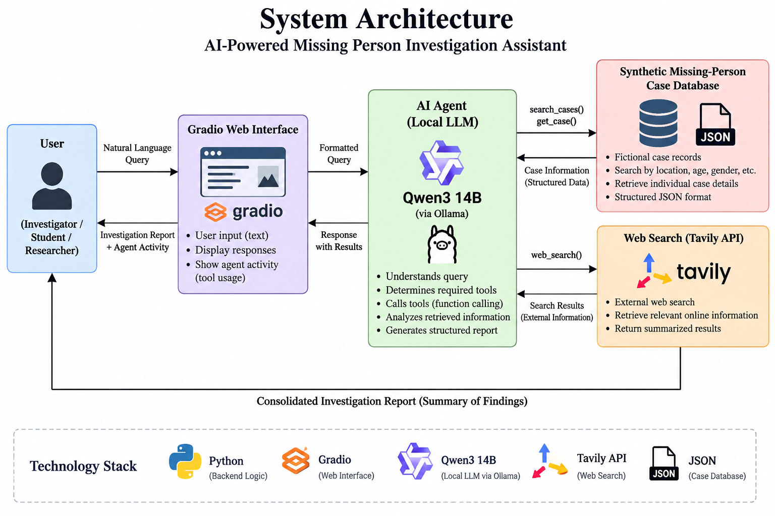

5.2 Working Principle
The system operates through a sequence of steps in which the local LLM acts as an intelligent agent capable of selecting and using different tools.

Step 1: User Query
The process begins when the user enters an investigation request through the Gradio interface. For example:
"Find missing people aged 18–25 who were last seen in Mumbai."
The query is passed from the Gradio interface to the Python backend.

Step 2: Query Interpretation
The Qwen3 14B model receives the query and interprets the user's requirements. It identifies relevant parameters such as:
- Location: Mumbai
- Minimum age: 18
- Maximum age: 25
The model then determines which available tool can provide the required information.

Step 3: Tool Selection
The agent selects an appropriate tool using function/tool calling.
For a database-based query, it can select:
search_cases()
For a request involving a specific case, it can select:
get_case()
When external information is required, it can select:
web_search()
The tool selection is determined by the LLM according to the requirements of the query.

Step 4: Case Database Search
When the search_cases() tool is selected, the system searches the synthetic JSON database according to the parameters provided by the agent.
For example:
Location = Mumbai
Age = 18–25
The matching records are returned to the AI agent.

Step 5: Individual Case Retrieval
If the user requests information about a specific case, the get_case() function retrieves the complete record associated with the requested case ID.
For example:
MP001
The system searches the database for the corresponding record and returns its available details to the agent.

Step 6: External Web Search
If the query requires information outside the synthetic database, the agent can use the web_search() tool. This function sends the relevant search query to the Tavily API.
Tavily retrieves relevant external search results, which are returned to the application and passed back to the local LLM.

Step 7: Information Analysis
The Qwen3 model receives the results returned by the selected tools. It analyzes the retrieved information and combines the relevant findings.
The model is instructed to distinguish between information retrieved from the synthetic database and information obtained through external web search. It is also instructed not to claim that a database record represents a confirmed real-world identity match.

Step 8: Report Generation
After analyzing the available information, the agent generates a structured investigation report. The report summarizes the relevant case records and, where applicable, external search findings.

Step 9: Displaying the Result
The final report is returned to the Gradio interface. The interface displays both:
- Agent Activity — showing the tools and operations performed.
- Investigation Report — containing the final response generated by the AI agent.
Thus, the complete working principle can be represented as:
User Query
↓
Gradio Interface
↓
Qwen3 14B Local LLM
↓
Understand Query
↓
Select Required Tool
↓
┌──────────────┬──────────────┐
│ │ │
▼ ▼ ▼
Search Get Case Web Search
Cases Details via Tavily
│ │ │
└──────────────┴──────────────┘
↓
Retrieved Information
↓
Qwen3 Analysis
↓
Investigation Report
↓
Gradio Interface
↓
User
This methodology enables the system to function as an AI agent rather than a conventional chatbot, because the LLM can interact with external tools, retrieve information, analyze the returned results, and use those results to construct its final response.

5.4 Simulation
The developed system was simulated and tested using the Gradio-based web interface to verify the complete AI-agent workflow. The simulation was performed using the locally deployed Qwen3 14B 64K model through Ollama, the synthetic missing-person case database, and the Tavily API for external web search.
During the simulation, an investigation query was entered through the Gradio interface in natural language. The query was passed to the local AI agent, which interpreted the requirements and determined the appropriate tool to use. Depending on the query, the agent could search the synthetic case database, retrieve the details of a particular case, or perform an external web search using Tavily.
For example, a query such as:
"Find missing people aged 18–25 last seen in Mumbai and investigate related information."
requires the agent to first identify relevant records from the case database and then use the web-search tool when external information is requested. The retrieved information is passed back to the Qwen3 model, which analyzes the results and generates a consolidated investigation report.
The simulation interface also displays the Agent Activity, allowing the execution of the agent's tools to be observed. Activities such as database searching, case retrieval, and Tavily web searching are displayed before the final investigation report is generated.
The simulation verifies the following functionalities:
- Natural-language query processing through the Gradio interface.
- Local LLM inference using Qwen3 14B through Ollama.
- Automatic tool selection by the AI agent.
- Synthetic case database searching using search_cases().
- Individual case retrieval using get_case().
- External web searching using web_search() and the Tavily API.
- Integration of retrieved information by the LLM.
- Generation of a structured investigation report.
- Display of agent activity through the Gradio interface.
The simulation confirms that the individual components of the proposed architecture can operate together as an integrated AI-agent system. The system successfully accepts a user query, determines the required information sources, invokes the appropriate tools, processes the returned information, and presents the final result through the web interface.
Figure 5.1 shows the developed Gradio interface and the corresponding investigation results obtained during the simulation.
Figure 5.1:
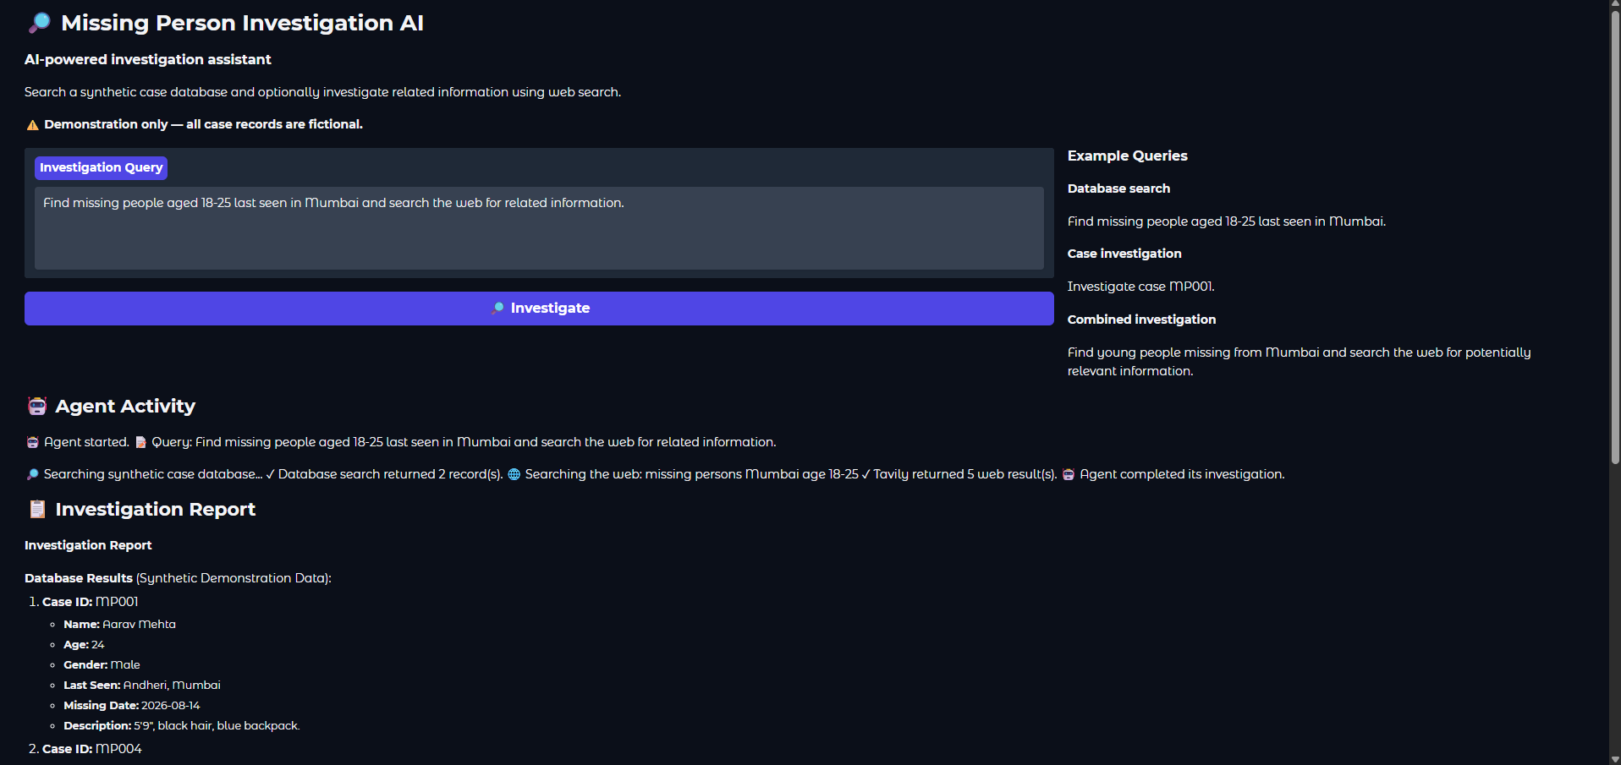
Figure 5.2:
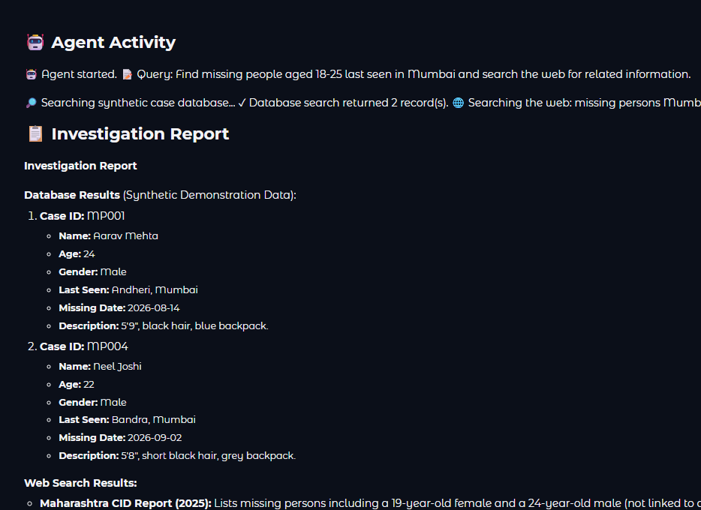

Chapter 6
Prior Art and Related Work (Literature Survey)

6.1 Introduction
Artificial Intelligence has increasingly been applied to missing-person investigations, information retrieval, image recognition, and automated decision-support systems. Existing research in the missing-person domain has largely focused on facial recognition, deep learning, image-based identification, surveillance systems, centralized databases, and geofencing. These approaches primarily attempt to identify or locate an individual using visual or geographical information.
For example, research presented at the 2022 International Conference on Applied Artificial Intelligence and Computing investigated AI-based missing-person detection using facial recognition techniques. The work compared different recognition approaches and demonstrated the potential of AI-based facial identification for missing-person applications. More recent work has continued to explore deep-learning and facial-recognition approaches for identifying missing individuals from photographs and surveillance footage.
In parallel with computer-vision-based research, recent developments in Large Language Models (LLMs) have introduced a different approach to intelligent information systems. Rather than concentrating exclusively on visual identification, LLM-based agents can understand natural-language instructions, interact with external tools, retrieve information, and reason over the retrieved results. Research such as ReAct and Toolformer has established important foundations for tool-using language-model systems.
The proposed project combines these developments from a different perspective. Instead of attempting to automatically identify a missing person from an image, the proposed system focuses on AI-assisted information retrieval and investigation. It uses a local LLM to interpret investigation queries, a structured case database for retrieving case information, and web search for obtaining additional external information.

6.2 Existing Technologies

6.2.1 Facial Recognition and Deep Learning
Facial recognition is one of the most common AI approaches investigated for missing-person identification. Such systems generally use photographs of missing individuals and compare facial features against images obtained from databases, cameras, or other sources.
A 2024 IEEE conference publication, Digital Vigilance: AI Solutions in the Quest for Missing Persons using face recognition with deep learning algorithms, proposed the use of facial recognition and deep-learning techniques to assist in locating missing individuals in environments such as public transportation areas and airports. The approach uses CNN-based facial recognition to compare and identify individuals.
Similarly, a 2025 IEEE conference publication proposed an AI-Powered Image-Based Missing Person Identification System using CNN-based feature extraction and comparison against a database of missing or located individuals. The work also considered structured storage and deployment mechanisms for a scalable identification system.
These systems are useful when suitable photographs or camera footage are available. However, they primarily focus on visual identification, whereas the proposed project focuses on natural-language investigation and information retrieval.

6.2.2 Centralized Missing-Person Tracking Systems
Another existing approach is the development of centralized platforms for storing missing-person information and coordinating searches.
The Missing Persons Comprehensive Tracking System (MPCTS) proposed in 2024 combines a centralized database with technologies such as facial recognition, deep learning, geofencing, notifications, and surveillance-related analysis. The system is designed to support law-enforcement organizations in managing missing-person information and identifying individuals.
Such systems demonstrate the usefulness of combining multiple technologies around a centralized case-management platform. The proposed project follows a simpler and more focused architecture, using a structured synthetic database as an information source for an AI agent.

6.2.3 LLM-Based Tool-Using Agents
Recent LLM research has moved beyond conventional question-answering systems toward agents that can interact with external tools.
The ReAct framework introduced an approach that combines reasoning and action, allowing language models to interact with external sources such as knowledge bases and environments. The research showed that integrating reasoning with actions can improve the interpretability and effectiveness of task-solving workflows.
The Toolformer research further demonstrated that language models can learn to determine which external APIs to call, when to call them, what arguments to provide, and how to incorporate the returned information into subsequent responses. The tools investigated included calculators, question-answering systems, search engines, translation systems, and calendars.
These concepts form an important technical foundation for the proposed project because the implemented system also allows the LLM to select between different tools.

6.2.4 Modular AI Architectures
The MRKL (Modular Reasoning, Knowledge and Language) architecture proposed a modular approach in which large language models are combined with external knowledge and reasoning modules. The research highlights that language models can be complemented by specialized modules when tasks require information or reasoning capabilities beyond the model itself.
The proposed system follows a similar modular principle by separating the language model from the case database and external web-search functionality.

6.3 Related Work

Study | Year | Main Approach | Relevance to Proposed System
AI for Detection of Missing Person | 2022 | AI and facial recognition | Demonstrates AI-based approaches for missing-person identification. (IEEE Xplore)
ReAct: Synergizing Reasoning and Acting in Language Models | 2022/2023 | LLM reasoning + external actions | Provides the conceptual foundation for tool-using AI agents. (arXiv)
Toolformer: Language Models Can Teach Themselves to Use Tools | 2023 | LLMs using external APIs | Demonstrates how language models can select and use external tools. (arXiv)
Generative Agents: Interactive Simulacra of Human Behavior | 2023 | LLM-based autonomous agents | Demonstrates architectures combining LLMs with memory, planning, and interaction. (arXiv)
Missing Persons Comprehensive Tracking System | 2024 | Centralized database, facial recognition, deep learning and geofencing | Demonstrates integrated technology for missing-person case management. (IEEE Xplore)
Digital Vigilance: AI Solutions in the Quest for Missing Persons | 2024 | CNN and facial recognition | Demonstrates deep-learning-based visual identification of missing persons. (IEEE Xplore)
AI-Powered Image-Based Missing Person Identification System | 2025 | CNN-based image identification | Demonstrates recent image-based AI approaches to missing-person identification. (IEEE Xplore)
Review of LLM-Based Agents | 2024 | Tool use, planning and feedback learning | Provides a broader classification of modern LLM-agent architectures. (arXiv)

6.4 Summary
The literature survey demonstrates that Artificial Intelligence has already been applied to missing-person problems through several technological approaches. Existing systems have primarily used facial recognition, CNN-based image analysis, surveillance cameras, centralized databases, geofencing, and automated notifications. These approaches are particularly useful when visual or geographical information is available.
At the same time, research into Large Language Model agents has introduced mechanisms through which language models can interact with external tools and information sources. ReAct demonstrated the integration of reasoning and actions, while Toolformer demonstrated the use of external APIs by language models. Modular architectures such as MRKL further established the value of combining language models with external knowledge and specialized modules.
Based on the reviewed work, the proposed project takes a different approach by concentrating on AI-assisted investigation and information retrieval rather than automated visual identification. The system combines a locally deployed Qwen3 14B model, a structured synthetic case database, and Tavily-based web search within an agentic workflow. This allows the project to demonstrate how modern LLM-agent techniques can be applied to an investigation-support scenario while keeping the prototype controlled through synthetic data.
The literature therefore provides the technical foundation for the proposed architecture while also highlighting the distinction between the project's information-retrieval approach and existing image-based missing-person identification systems.

Chapter 7 Applications and Deployment Areas

7.1 Applications
The proposed AI-Powered Missing Person Investigation Assistant can be applied to information retrieval and investigation-support scenarios where information needs to be collected from multiple sources and organized into a meaningful report. The system is designed as a prototype and uses synthetic missing-person records; therefore, the following applications represent potential uses of the proposed architecture rather than claims of real-world deployment.

7.1.1 Missing-Person Case Information Retrieval
The system can assist users in searching a structured database of missing-person records using natural-language queries. Users can specify parameters such as age, gender, location, or other available case attributes without manually constructing database queries. The search_cases tool processes these requirements and retrieves matching records.

7.1.2 Individual Case Investigation
The system can retrieve detailed information about a particular case using its case ID. The get_case tool provides the available information associated with the selected record, after which the local LLM can organize the information into a structured investigation summary.

7.1.3 Web-Based Information Search
The integration of the Tavily web-search API allows the agent to search external web sources when additional information is requested. This can be useful for demonstrating how an AI agent can combine information from a structured internal database with information obtained from external sources.

7.1.4 AI-Assisted Investigation Reports
The system can combine the information obtained from different tools and generate a structured investigation report. Instead of presenting disconnected search results, the local Qwen3 14B model organizes the retrieved information into a readable summary. This demonstrates the usefulness of LLMs for information organization and analysis.

7.1.5 Investigation Workflow Demonstration
The application can be used as an educational and experimental platform for demonstrating AI-agent concepts. It shows how a local LLM can interpret a natural-language request, select appropriate tools, retrieve information, analyze the results, and generate a final response.

7.1.6 Information Retrieval Research
The modular architecture can also be used for experimenting with different information-retrieval techniques, local LLMs, search APIs, structured datasets, and tool-calling mechanisms. Individual components can be modified without requiring the complete system to be redesigned.

7.1.7 Privacy-Conscious AI Experimentation
Since the prototype uses synthetic missing-person records, it provides a controlled environment for demonstrating an investigation-assistance workflow without directly exposing real personal information. This makes the system suitable for academic experimentation and development.

7.2 Deployment Areas
The proposed system can potentially be deployed or adapted for different environments where information from multiple sources needs to be searched and organized. Any real-world deployment involving actual missing-person information would require appropriate authorization, privacy protection, data verification, authentication, and security mechanisms.

7.2.1 Academic and Educational Institutions
The system can be deployed in academic environments as a demonstration platform for subjects related to Artificial Intelligence, Machine Learning, Natural Language Processing, Large Language Models, and software engineering. Students can study concepts such as tool calling, local LLM inference, API integration, and agent-based architectures.

7.2.2 Research and Development Environments
Research organizations can use the architecture as a prototype for studying LLM-based agents that interact with structured and unstructured information sources. Different language models, search systems, databases, and retrieval techniques can be evaluated using the modular architecture.

7.2.3 Investigation Support Systems
With appropriate security and verified data sources, a similar architecture could be adapted as an information-support component for investigation workflows. The system could provide investigators with a natural-language interface for retrieving and organizing information from authorized databases and external sources.

7.2.4 Non-Governmental and Social Organizations
Organizations involved in missing-person assistance could potentially use an adapted version of the system to organize information from authorized case databases and publicly available sources. Such deployment would require strict controls for personal data, source verification, and access permissions.

7.2.5 Internal Enterprise Information Systems
The same architecture can be generalized beyond missing-person cases to enterprise systems where employees need to search multiple information sources. The local LLM can act as a reasoning layer between users and different internal tools or databases.

7.2.6 Local or On-Premises Deployment
Because the primary language model is executed locally through Ollama, the architecture can be adapted for environments where local processing is preferred. This reduces dependence on external LLM inference services for the core reasoning process. External services such as Tavily can still be enabled when web-based information retrieval is required.

7.2.7 Future Cloud Deployment
The application can also be extended to a cloud-based environment by deploying the Python application, database, and supporting services on a suitable server. Authentication, encrypted communication, access control, database security, logging, and privacy mechanisms would need to be added before handling sensitive or real-world information.
Overall, the proposed system demonstrates how a local LLM, structured database, web-search service, tool-calling framework, and interactive interface can be combined into an AI-assisted information retrieval system. Its modular design allows the same underlying architecture to be adapted to different information-intensive applications while maintaining a controlled separation between data retrieval, reasoning, and presentation.

Chapter 8 Conclusion and Future Scope

8.1 Conclusion
The AI-Powered Missing Person Investigation Assistant Using Local LLM and Web Search demonstrates the application of Artificial Intelligence and Large Language Models in an information-intensive investigation workflow. The proposed system combines a locally running Qwen3 14B Large Language Model through Ollama, a structured synthetic missing-person database, the Tavily web-search API, and a Gradio-based interactive interface.
The developed system allows users to interact with the application using natural-language queries instead of manually performing separate database searches and web searches. Based on the user's request, the AI agent can select appropriate tools such as search_cases, get_case, and web_search. The information obtained from these tools is then provided to the local language model, which analyzes and organizes the results into a structured investigation report.
One of the important aspects of the project is the use of a local LLM. Running Qwen3 14B through Ollama allows the core reasoning component to operate locally, reducing dependence on external language-model inference services. At the same time, the integration of Tavily demonstrates how an AI agent can access external information when required.
Overall, the project successfully demonstrates the integration of local LLM inference, AI-agent tool calling, structured data retrieval, web search, and interactive application development into a single prototype. The developed architecture provides a foundation for further research into AI-assisted information retrieval and investigation-support systems while highlighting the importance of privacy, verification, and responsible deployment.

8.2 Future Scope
The system can be further enhanced through:
- Integration with verified missing-person databases.
- Image-based and facial-recognition search.
- Retrieval-Augmented Generation (RAG) for larger document collections.
- GIS and map-based location analysis.
- Multilingual support.
- Improved AI-agent planning and additional tools.
- User authentication and role-based access control.
- Enhanced privacy and security mechanisms.
- Mobile and cloud-based deployment.
- Human verification before treating retrieved information as confirmed.
These improvements could help develop the prototype into a more comprehensive AI-assisted investigation-support system while maintaining appropriate privacy, security, and ethical safeguards.

References / Bibliography
[1] S. Yao, J. Zhao, D. Yu, N. Du, I. Shafran, K. Narasimhan, and Y. Cao, “ReAct: Synergizing Reasoning and Acting in Language Models,” International Conference on Learning Representations (ICLR), 2023.
[2] T. Schick, J. Dwivedi-Yu, R. Dessì, R. Raileanu, M. Lomeli, L. Zettlemoyer, N. Cancedda, and T. Scialom, “Toolformer: Language Models Can Teach Themselves to Use Tools,” 2023.
[3] E. Karpas, O. Abend, Y. Belinkov, B. Lenz, O. Lieber, N. Ratner, Y. Shoham, et al., “MRKL Systems: A Modular, Neuro-Symbolic Architecture that Combines Large Language Models, External Knowledge Sources and Discrete Reasoning,” 2022.
[4] A. Yang, A. Li, B. Yang, B. Zhang, B. Hui, B. Zheng, B. Yu, et al., “Qwen3 Technical Report,” 2025.
[5] S. R. et al., “AI for Detection of Missing Person,” 2022 International Conference on Applied Artificial Intelligence and Computing (ICAAIC), 2022, DOI: 10.1109/ICAAIC53929.2022.9792672.
[6] “Digital Vigilance: AI Solutions in the Quest for Missing Persons using Face Recognition with Deep Learning Algorithms,” 2024 2nd International Conference on Artificial Intelligence and Machine Learning Applications Theme: Healthcare and Internet of Things (AIMLA), 2024, DOI: 10.1109/AIMLA59606.2024.10531327.
[7] “Missing Persons Comprehensive Tracking System with Secure Login-Based Interface for Displaying Missing People Data, Found Person Details,” 2024 Second International Conference on Advances in Information Technology (ICAIT), 2024, DOI: 10.1109/ICAIT61638.2024.10690340.
[8] “AI-Powered Image-Based Missing Person Identification System,” 2025 Third International Conference on Augmented Intelligence and Sustainable Systems (ICAISS), 2025, DOI: 10.1109/ICAISS61471.2025.11042201.
[9] Qwen Team, “Qwen3,” Qwen Documentation / Technical Resources, 2025.
[10] Ollama, “Ollama: Run Large Language Models Locally,” 2025.
[11] Gradio, “Gradio Documentation,” 2025.
[12] Tavily, “Tavily Search API Documentation,” 2025.
[13] Python Software Foundation, “Python 3 Documentation,” Python Software Foundation.
[14] GitHub, “GitHub Documentation,” GitHub, Inc.

